Task Flow Step

Objective

TaskFlowStepExecutor executes multiple tasks. First Initial task executed based on an initial task id from the user, if they don't provide then consider the value as init after completion of task execution, gets the status based on the status get the next task from the task map mentioned in the next property.

UI

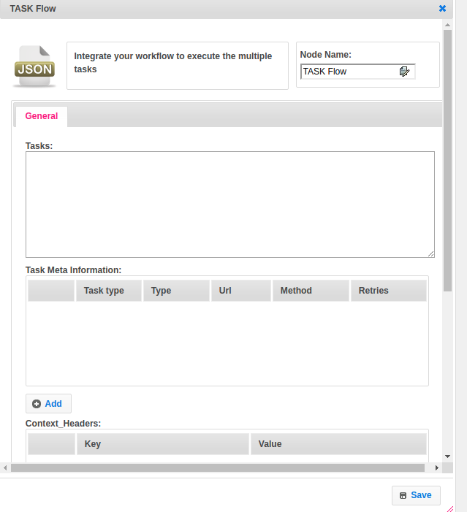

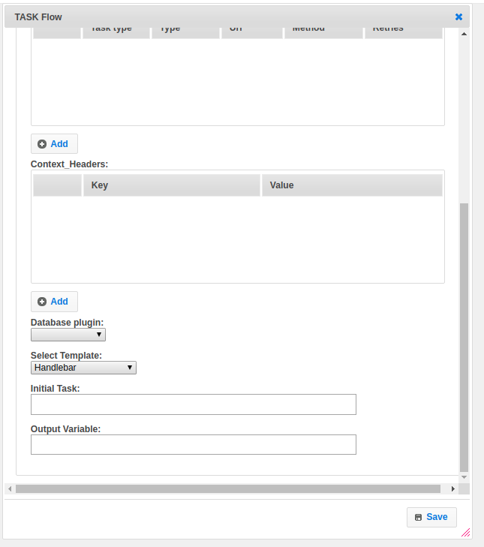

## Attributes

|  |  |
| --- | --- |
| **Attributes** | **Description** |
| **1. Tasks** | Tasks contain an array of JSON. |
| **2. Task Meta Information** | Task metadata contains an array of maps. Each map contains an object of TaskMeta |
| **3. Context_Header** | An array of maps.  Key as header name  Value as header value. |
| **4. Database Plugin** | Provide database plugin information. |
| **5. Select Template** | Select Template used to set the value type.  Value types are two types.  1.hb-HandleBars  2.ftl-Freemarker Template Language. |
| **6. Initial Task** | Initial task name.declared by default as init. |
| **7. Output Variable** | Used to store the response of the request. |

## Executor Description:

Prepare Task Meta Info map. Prepare the task object. Convert an array of JSON into task object.Create a Task map object and put task_id as key and task object as value. Execute the task, start with initial task id init. Based on type attribute value in tasks object it will execute the rest calls in a task metadata list. Depends on the success or failure the next task will execute.